Functions of Data Link Layer and Physical Layer

Xinran Hu

Harrisburg University

Abstract

In this paper, I’ll study the role of data link layer and physical layer within the Open Systems Interconnect (OSI) model. The OSI model is a seven layered model abstraction of the complicated network technology stack. Based on the OSI model, a sequence of layers provide various encapsulation and decapsulation operations during the transfer of information over network. At the bottom of the OSI layered model, two of these layers, namely, the physical layer and data link layer serves as foundation of all upper layers. They provide flexible and easy to use means of transferring data through local network build with various types of physical medium. I will study the responsibility of these two layers as well as several related technologies and protocols.

**Introduction**

Computer has become an essential part of our society. It has played a crucially role on economics, transportation, education and almost every aspects of our lives. The most important and fastest-growing technology in computer era is the Internet. It has completely changed the tradition in many areas of life. With the Internet connected computers all over the world together, it enabled communication between people from different continents at a speed of light and a level of convenience never seen before. The diversity of the content of internet communication also far suppresses any forms of communications seen before. Internet can transfer text, picture, voice and video. Studying the principle of how internet work will benefit our future greatly. Therefore in this paper, I am going to study the technologies that powers internet. I’ll pay specific attention to the well-known OSI seven layered model and two lower layers in this model, namely the data link layer and physically layer.

**OSI Seven Layer Model**

The Open Systems Interconnect (OSI) model divides the computer network into seven separate layers, each layer has its specific functions and tasks. This model is developed and set by the International Standards Organization (ISO), thus it is also sometimes called the ISO / OSI standard.

As shown in Figure 1, the OSI model consists of seven layers. Each layer is built on top of another layer and only communicates with the layer that immediately above and below it. The layers are arrange in an top-to-bottom order corresponds to its relationship to software-to-hardware. The higher layers are closer to software applications and lower layers are closer to hardware device. I will start my discussion from the bottom layer and gradually go up to the top layers.

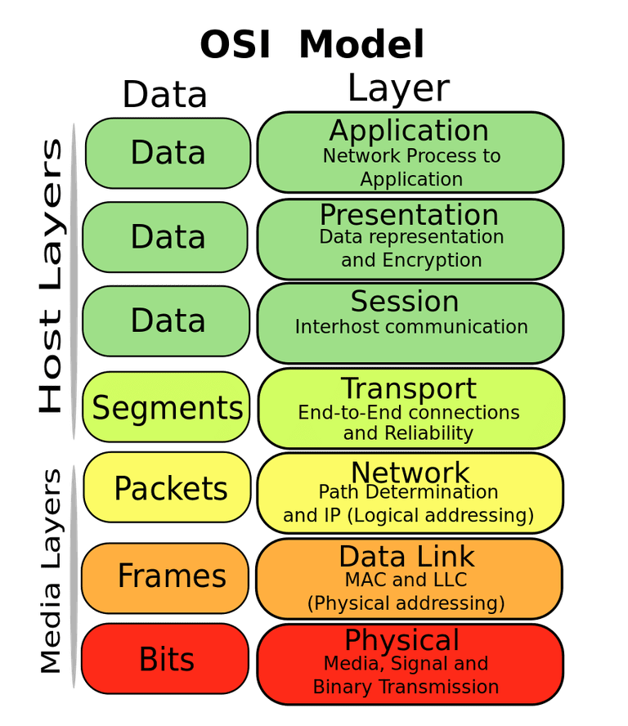

*Figure 1, The OSI seven layer model. It shows the order of seven layers and their name and functions.*

*Source: Internet*

**Layer 1 - Physical Layer**

The physical layer is the first layer in the OSI model. It defines specifications that closely related to the physical properties of network devices. For example, it defines the type of transmission medium, such as infrared or optical fiber. Each of these medium has a different property of performance and cost. It also defines connector specifications, such as number of pin foot in a connector. These specifications will dictate how signals will be transferred among sections of the network. It also defines the transmission signal specifications, such as how voltage is set and what is transmission distance for each type of the medium. Physical layer is the layer that mostly related to hardware devices.

**Layer 2 - Data Link Layer**

On top of the physical layer is the data link layer. One of the main responsibilities of data link layer is receiving bit streams from physical layer, examining the correctness of bit streams and checking MAC address of the recipient. Based on the MAC address, the data link layer then decides either to pass the communication to upper layers or to ignore the communication. Another important responsibility of data link layer is receiving packet or datagram from upper layer, encapsulating the data payload with the correct header and trailer, then data link layer sends frame to the physical layer to transmit as bit stream. Therefore, it is a bridge that sits in between hardware and software.

Beside these two tasks, other examples of data link layer tasks also include

(1) CRC Error Detection

(2) Flow Control

**Layer 3 - Network Layer**

The network layer primarily provides routing services in inter-network communication. Two major functions are (1) defining unique address of each host and (2) routing between two hosts given an address. The most famously known example of these routing protocols at network layer is the Internet Protocol (IP). It is the layer 3 protocol that being used by the Internet right now.

**Layer 4 - Transport Layer**  
In addition to the routing provided by the network layer, the transport layer provides more functionality to facilitate communication between two processes on different hosts. Transport layer also provide more error checking and ensures the reliability of packet delivery. It also provides flow control to avoid network congestion. The most well-known protocol in the layer is the Transmission Control Protocol (TCP). TCP along with IP makes up the TCP/IP suite which is widely used by current internet.

**Layer 5 - Session Layer**  
The session layer abstracts away the details of establishing and maintaining a session of communication. It provides software developers a simplified review of communication with a remote host.

**Layer 6 - Presentation Layer**  
The presentation layer transfers the information with meaningful conversions such as coding conversion, data compression and data encryption and decryption. Most important feature of this layer is data encryption and decryption. Many internet applications with sensitive information transfer will almost always employ some kind of encryption to avoid potential risk of losing information.

**Layer 7 - Application Layer**

The application layer is highest layer in the OSI model. This is essentially the internet a human user directly interacts with. It provides a wide range of application protocols such as The Hypertext Transfer Protocol (HTTP), [File Transfer Protocol(FTP)](https://en.wikipedia.org/wiki/File_Transfer_Protocol)and [Simple Mail Transfer Protocol](https://en.wikipedia.org/wiki/Simple_Mail_Transfer_Protocol)(SMTP). These are the protocols that we, as a human user, use to browse a website, download a file and sending an email.

The importance of the OSI model is that it creates a clear division of responsibilities. Each level is responsible for its own tasks thus the overall complexity is reduced and the whole system is much easier to debug and maintain. It allows different protocols to be replaced and upgraded along the way which further improve the level of usability and modularity of internet technology stack.

With a good overall understanding of the OSI model, let’s now focus on two lowest layers and discuss the details of how these two layers function and interact with other layers.

**The function of the physical layer**

The common understanding of function of the physical layer is to ensure the completion the transmission of the bit stream. This task can be divided into several sub-tasks such as, translating the original into signals, transmitting signals over a variety of physical medium, and translating signals back into data. Therefore, the physical properties of medium and the encoding-decoding specifications are both important aspects of the physical layer.

**3.1 Different kind of transport medium**

The most visible aspect of physical layer is the transport medium. Different mediums have different physical characteristics that make each type of medium suitable for different requirements of task. Channel capacity and cost are the two most important aspects, amongst all the features of a medium, that influent the choice of medium. Let’s see some of the most common examples of medium and their corresponding cost and channel capacity.

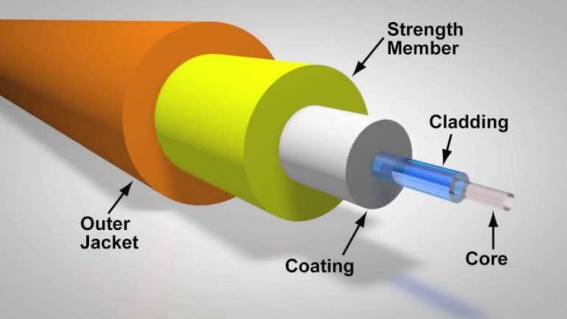

*Figure 2. Illustration of an Optical Fiber*

*Source, Internet*

Optical Fiber, shown in Figure 2, uses light a signal. It has the highest capacity (about 100 GB/s) compared to other types of medium. Optical fiber is used main to sever as the high-way that connects two large, distant host groups. For example, the Trans-Pacific Express (TPE) Cable System, which connects China and the United States of America are built with optical fibers. However, despite the excellent channel capacity, optical fiber is also the most expensive types of medium. Therefore, it is only used for applications that requires large bandwidth.

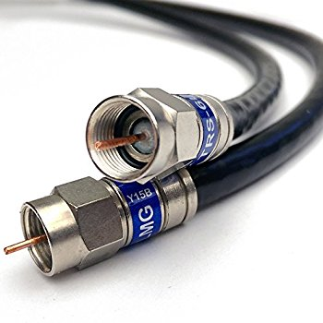

*Figure 3. Coaxial Cable*

*Source: Internet*

Coaxial Cable is a much more inexpensive medium, compared to optical fiber. But it can still provide up to 100MB/S of capacity, therefore it is a popular type of medium in household use. It is also commonly found in most of the LAN.

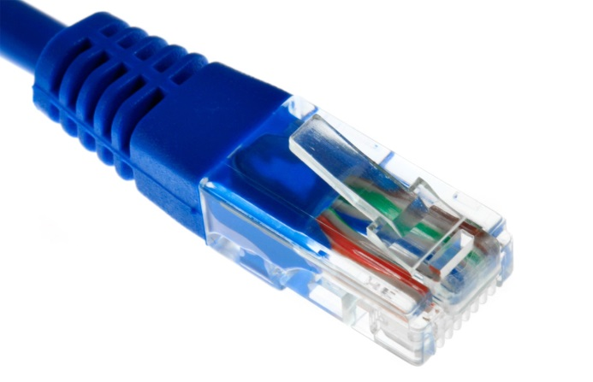

*Figure 4. Ethernet Cable*

*Source: Internet*

Ethernet cable is made of twisted pair cable. They are cheaper than coaxial cable but also provides 10 MB/s to 100 MB/s capacity therefore also very widely used in household LAN

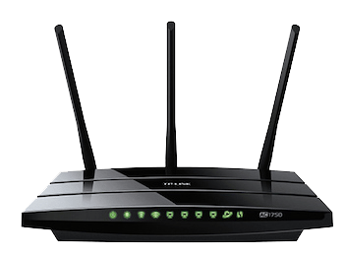

*Figure 5. Wifi*

*Source: internet*

Besides wired medium, wireless medium are the other types of medium used by networks. WiFi is the most commonly used wireless medium for both home and commercial usage. Wifi completely frees devices thus allows a very convenient access to network. It provides up to 450MB/s capacity but it is more susceptible to interference than wired medium.

**Bit encoding of analog signal**

Another importance aspect of physical layer is to determine how bits (0 and 1) should be represented by a physical signal. Different protocol may specify different methods. Each of the protocol may only work for a specific type of physical medium as well. The most common types of the signal is wave, either electrical wave or radio wave. Let’s take wave for example and see how bit information can be encoded in several different ways.

Recall that a wave can be described by its amplitude, frequency and phrase. Similarly, we can use each of these properties to encode bit as well.

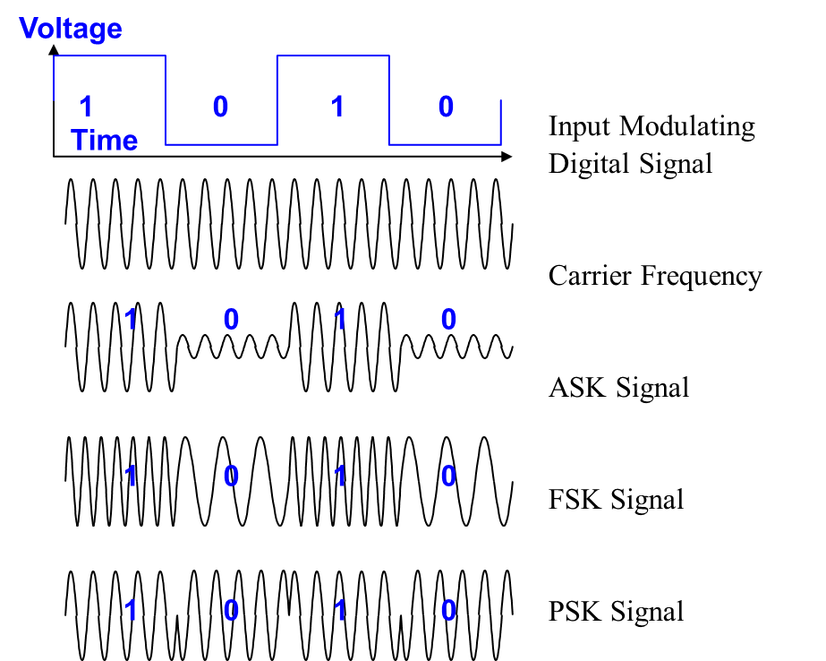

*Figure 6. Illustration of different ways of encode bit with wave*

*Source: Internet*

**By Amplitude**

Wave will have same frequency but different amplitude to signal a 1 bit or a 0 bit. Usually, higher amplitude means 1 and lower means 0

**By Frequency**

Wave will have same amplitude but different Frequency to signal a 1 bit or a 0 bit. Usually, higher Frequency means 1 and lower means 0

**By Phase**

Wave will have same frequency and amplitude, but phase may change from time to time. Usually 0 phase mean 0 and 180 means 1

**Functions of Data Link Layer**

The data link layer adds the header and trailer to the IP datagram transmitted from the network layer. The header and trailer has specific bit patterns that defined by protocol such that a receiver knows the beginning and the end of the frame based on the protocol. The main role of the header and trailer is to delimitate a frame (to determine the boundaries of the frame), but they also contain important control information. For example, MAC address is contained in the header to identify the intent receiver of the bit stream. A realistic communication link also inevitably generates bit errors, that is, a certain bit error rate (BER), which is related to the signal-to-noise ratio of the channel. In order to ensure data transmission reliability, some error detection measures have been added to the trailer, such as cyclic redundancy check (CRC). Error checking at the data link layer requires dividing the data into frames, each of which is preceded by a redundant code, frame-by-frame transmission and verification. However, this can only guarantee error-free transmission of frames (no bit errors) and cannot guarantee frame loss, repetition or out-of-sequence (no transmission error).

**Tasks of Data link Layer**

The basic task of the data link layer includes

1. Encapsulate packet or datagram into frame and decapsulate frame into packet or datagram
2. CRC Error detection
3. MAC addressing
4. Flow Control

**Data link layer Encapsulation**

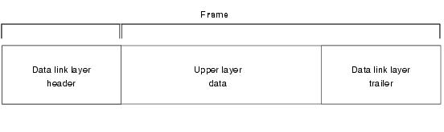

*Figure 6. Layout of a Data Link Layer Fraame*

*Source Internet*

Encapsulation at data link layer means after receiving data from upper layer, data link layer prepends and appends a header and trailer to the data payload. This creates a data unit called frame. The header includes a bit sequence that signifies the beginning of a data frame and MAC address of the receiver and sender. The trailer usually has the bit information for error detection and a bit sequence that signifies the ending of a data frame.

**Sub-layers of Data link Layer**

The data link layer is further divided into two sub-layers: Logical Link Control (LLC) and Media Access Control (MAC) layer

**Logical Link Control Layer**

LLC is the upper layer of the two, meaning it’s closer to software. It offers two connectionless and one connection-oriented modes of operation.

The first mode is a non-reply non-connection oriented way, it allows to send frames (a) to a single destination address (point to point agreement or single point transmission); (b)To multiple destinations in the same network (multicast); (c)To all addresses in the network (broadcast transmission). The second mode is a connection-oriented mode of operation, to number each frame, the receiver ensures that they are received in the order they are sent and that no frames are missing. The use of sliding window flow control protocol allows fast sender can also flow to the slow receiver. The third mode is a reply without connection. It is limited to point-to-point communications.

LLC also performs Cyclic Redundancy Check **(**CRC) to detect errors occurred during transmission. CRC is a way of detecting bit error in the payload but not error correction. It works by using a hash function which produces a fixed-digit checksum based on payload data. This checksum is mainly used to detect errors that may occur after data is transmitted or saved. Checksum are calculated and appended to the data before being transmitted or stored, and the recipient then checks to see if the data has changed

**Media Access Control Layer**   
MAC is the lower layer of the two. The primary task of MAC layer is to use MAC address to determine the correct recipient within a local network. A MAC address is a 48 bit sequence that divided into a manufacture id and device id (Shown in Figure 6). It is crucial that every device on the same local network has a unique MAC address; otherwise the network is not function correctly.

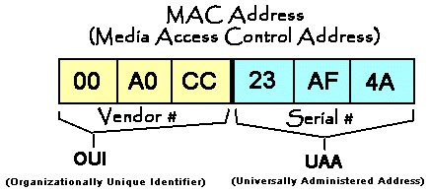

*Figure 6. Example of MAC address*

*Source Internet*

**NIC card - Data Link Device**

The most common data link layer device is a Network Interface Controller card (NIC). A NIC card is a piece of computer hardware designed to allow a computer to communicate over a computer network. Each NIC has its MAC address hardcode so it allows devices to identify each other by cable or wirelessly

**Flow Control**

Flow control is the act of regulating the rate of data transmitted over in a network. When the incoming data exceed the capability of processing, Flow control mechanism kicks in and notifies the sender of that data to reduce or cease sending additional data. Common flow control technique includes Stop-and-wait and Sliding Window. For example, Stop-and-wait method would require the sender to stop sending data until an acknowledgement is received from the receiver.

**History of IEEE 802 standards**

IEEE 802 standards are a set of standard and protocol that set up by Institute of Electrical and Electronics Engineers (IEEE) for both the physical layer and data link layer. The first IEEE 802 standard is created in February 1980, hence the 802 standards. It has since developed many well-known protocol for different type of physical medium. For example, the 802.3 standard is for Ethernet and 802.11 is for WiFi. These protocols have derived into many versions as well. For example, 802.11 has sub versions of a/b/n/g. In general, these protocols describe how data frame should be encoded and decoded within their respective network.

**PPP – yet another example of Data Link Layer Protocols**

As mentioned before, one important property of OSI layer model is to allow easy replacement of protocols at different layers. Therefore, the 802 protocol can be replaced by another protocol. For example, the Point-to-Point Protocol (PPP) is another data link layer protocol that establishes a direct connection between two computers. PPP also provide the same set of operations such as Flow control and error detection. Because the PPP and 802 are interchangeable in terms of the function they provides, computers programs can easily switch between networks that employ 802 and PPP without any change.